Expression of Interest Form
Town & Village Renewal Scheme 2023
BUILDING ACQUISITION MEASURE

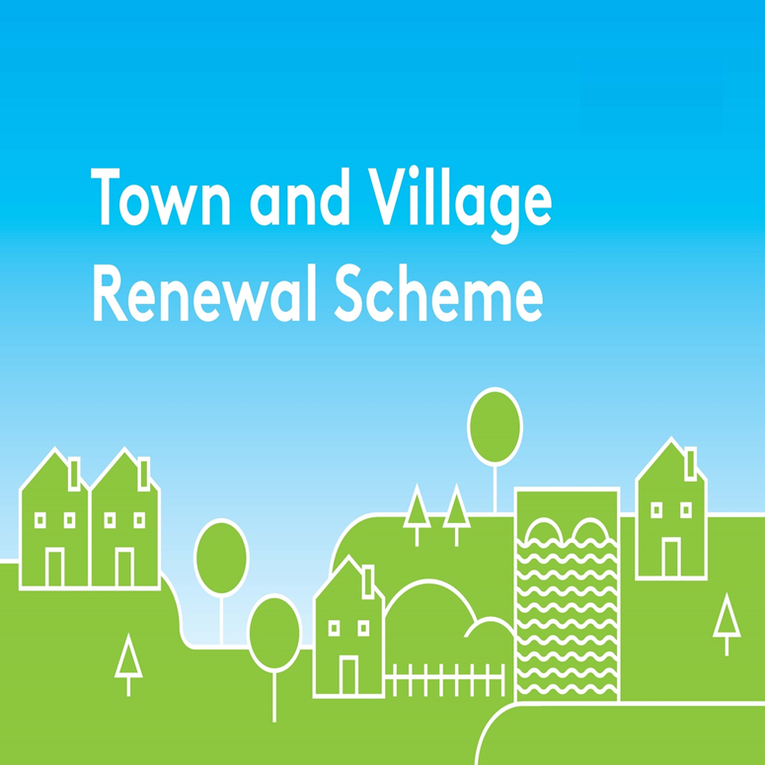
Please complete this Expression of Interest form
and return it to your Local Authority designated contact.

Town & Village Renewal Scheme 2023

Town/Village covered:

Amount of Funding Requested:

Applicant Group:

Applicant Contact Name:

Applicant Contact Address:

Applicant Contact Telephone Number:

Applicant Email Address:

- Please provide the Address and EIRCODE of the building to be purchased and sale price, including a series of photographs and associated mapping.
Confirm tenure is in order to facilitate sale completion on/before 15th September 2023.
( If there is a current for sale advertisement online please provide details of same or
a link to the ad):

- Please provide a brief background to the selected building, eg description incl: age, construction, location, importance in the townscape, historic value, previous use, is the building vacant and/or derelict, how long has it been vacant, etc:

- Evidence the need and the demand for the building

- Outline the proposed plan/use for the building, include eg Business Plans,
Feasiblity Studies, Health Check, Regeneration Strategies etc

- Has funding for this project ever been sought from other sources?
Yes No

(If "YES" yes please specify from what source and if funding was provided)

- Who are the specific project stakeholders/community partners in this project?
(Chamber of Commerce, Community group, etc.).

- Confirm in writing that the purchase of the building will be completed and all relevant draw down information will be submitted to the local authority before 15th September 2023.

DECLARATION
I hereby confirm that I have read and understand this document. I request that consideration be given in support of the project as outlined above.

Signature __________________________________________________

Position __________________________________________________

Date __________________________________________________

CLOSING DATE FOR RECEIPT OF EXPRESSIONS OF INTEREST:
2pm Thursday 20th April 2023
Completed forms should be returned by e-mail to TVR.BAM2023@donegalcoco.ie before 2pm on Thursday 20th April 2023
Late Expressions of Interest cannot be considered.

